**Assignment 1 Javascript Essentials JAN 2021**

**Question 1** What will the code below output to the console and why ? console.log(1 + "2" + "2"); console.log(1 + +"2" + "2"); console.log(1 + -"1" + "2"); console.log(+"1" + "1" + "2"); console.log( "A" - "B" + "2"); console.log( "A" - "B" + 2);

<!DOCTYPE html>

<html>

<head>

<title></title>

</head>

<body>

</body>

<script type="text/javascript">

console.log(1 + "2" + "2");

console.log(1 + +"2" + "2");

console.log(1 + -"1" + "2");

console.log(+"1" + "1" + "2");

console.log( "A" - "B" + "2");

console.log( "A" - "B" + 2);

</script>

</html>

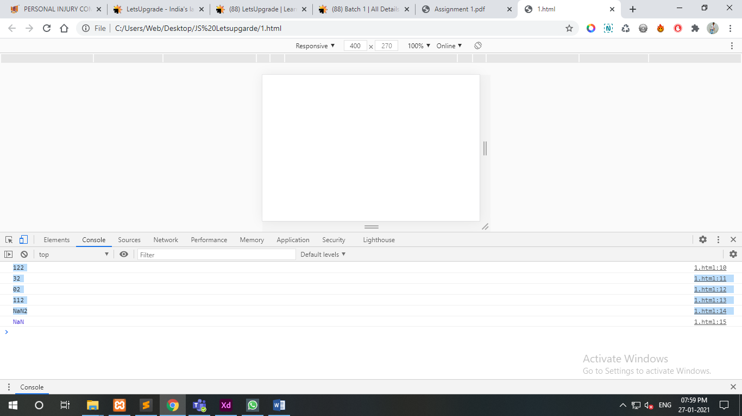

**Question 2** You are given a variable “marks”. Your task is to print: - AA if the mark is greater than 90 - AB if the mark is greater than 80 and less than or equal to 90 - BB if the mark is greater than 70and less than or equal to 80 - BC if the mark is greater than 60 and less than or equal to 70 - CC if the mark is greater than 50 and less than or equal to 60 - CD if the mark is greater than 40 and less than or equal to 50 - DD if the mark is greater than 30 and less than or equal to 40 - FF if the mark is less than or equal to 30

<!DOCTYPE html>

<html>

<head>

<title></title>

</head>

<body>

</body>

<script type="text/javascript">

var msg = 'enter the percentage of student:';

//printing message for user input

var a = prompt(msg);

if(a>90)

{//if percent > 85 --A

document.write('Grade - AA');}

else if(a<=90 && a>80)

{//80<percent80=85 --A

document.write('Grade - AB');}

else if(a>70 && a<=80)

{//70<percent<=80 --B

document.write('Grade - BB');}

else if(a>60 && a<=70)

{//60<percent<=70 --C

document.write('Grade - BC');}

else if(a>50 && a<=60)

{//40<percent<=60 --D

document.write('Grade - CC');}

else if(a>40 && a<=50)

{//40<percent<=60 --D

document.write('Grade - CD');}

else if(a>30 && a<=40)

{//40<percent<=60 --D

document.write('Grade - DD');}

else if(a<=30)

{//40<percent<=60 --D

document.write('Grade - FF');}

</script>

</html>

